RDD IN PYSPARK
Agenda
- Introduction
  - Features
  - Benefits
  - Limitations
- SparkSession
- RDD Creation
- RDD Partitions
- RDD Operations
  - Transformations
  - Actions
- Types of RDD
- Shuffle Operations
- Persist and Cache
Introduction
Resilient Distributed Datasets (RDD) are PySpark's fundamental data structure, representing an immutable, distributed collection of objects. RDDs are logically partitioned, enabling their processing across multiple nodes in a cluster. They can hold any type of Python, Java, or Scala objects, including user-defined classes.
PySpark leverages RDDs to perform fast and efficient MapReduce operations.
An RDD is formally defined as a read-only, partitioned collection of records. It can be created through deterministic operations on data stored in stable storage or derived from other RDDs. RDDs are fault-tolerant and support parallel processing of elements.
As PySpark's core abstraction, RDDs enable distributed computation by splitting data into partitions and processing them simultaneously across a cluster.
Key Features of RDD:
- Resilient: Built to recover from failures.
- Distributed: Operates across multiple machines in a cluster.
- Dataset: Represents partitioned collections like arrays, tables, tuples, etc.
Benefits of RDD:
- Fault Tolerance: RDDs can automatically recover lost data due to their lineage information, ensuring reliability in case of failures.
- Parallel Processing: Data in RDDs is divided into partitions, allowing operations to run in parallel across a cluster for faster computation.
- Flexibility: RDDs support both structured and unstructured data, making them versatile for different data processing needs.
- Immutability: RDDs are immutable, ensuring consistency and eliminating the risk of accidental data modification.
- Lazy Evaluation: Operations on RDDs are not executed immediately, enabling Spark to optimize the computation by reducing unnecessary data shuffling.
Limitations of RDD:
- Lack of Schema: RDDs do not have a schema, making them less efficient for structured data compared to DataFrames or Datasets.
- Verbose Code: Operations on RDDs require more complex, low-level code compared to the SQL-like simplicity of DataFrames.
- Performance: RDDs are not optimized by the Catalyst engine, leading to slower execution compared to DataFrames and Datasets.
- Memory Usage: RDDs may consume more memory as they do not have built-in optimizations for memory management like DataFrames.
- Steeper Learning Curve: Understanding and using RDDs requires knowledge of functional programming and Spark’s internals, which may be challenging for beginners.
SparkSession:
- A SparkSession is the entry point to using PySpark. It's like the "main hub" for working with Spark functionality.
- It allows you to interact with Spark features like RDDs, DataFrames, and Datasets.
Ned of SparkSession:
- Without a SparkSession, you cannot run any Spark tasks (e.g., reading data, processing it, or writing results).
- It connects your Python program to the Spark cluster or local system.

How to create a SparkSession:
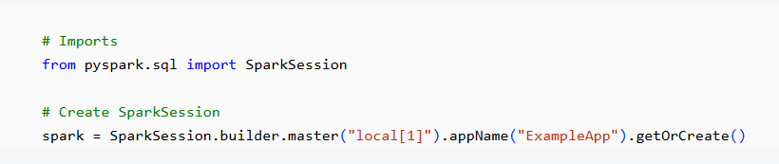
Explanation:
- master("local[1]"): Specifies where Spark will run: "local[x]": Run Spark locally on your machine. Replace x with the number of CPU cores to use. For example: local[1]: Use 1 CPU core. local[*]: Use all available CPU cores. In real-time applications, this will be replaced by spark-submit with options like yarn (for cluster).
- appName("ExampleApp"): Sets the name of your application. This name appears in Spark's UI to help you track running jobs.
- getOrCreate(): Returns the existing SparkSession if one is already created, or initializes a new one.
NOTE: In PySpark, we import from the pyspark.sql module because Spark SQL is the primary library used for working with structured and semi-structured data in PySpark. The pyspark.sql module provides the necessary tools for managing data as DataFrames and performing SQL-like operations, making it a critical part of working with PySpark.
RDD Creation
RDDs (Resilient Distributed Datasets) can be created in PySpark using various methods depending on the source of the data. Below are the primary methods for creating RDDs:
1. Creating RDD from a Python List using parallelize()
The parallelize() method is used to create an RDD from an existing collection in memory. This is suitable for testing and small-scale applications where the data is already loaded in the driver program.
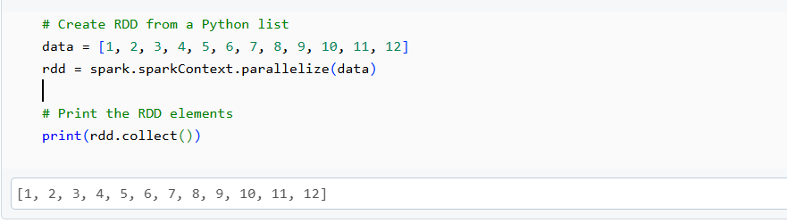

2.Creating RDD from an External Text File using textFile()
The textFile() method reads data from a text file and creates an RDD. Each line in the file becomes an element of the RDD.
NOTE: First, upload text file to dbfs and then copy the path from there instead of directly copying the path from location. The data which we have used is sample data which consists of 4 lines with random data.
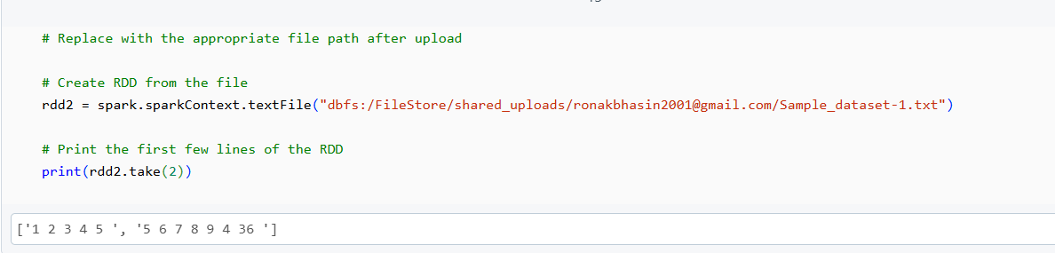

3. Creating RDD from Whole Files using wholeTextFiles()
The wholeTextFiles() method reads entire files into an RDD as key-value pairs. The key is the file path, and the value is the file content.
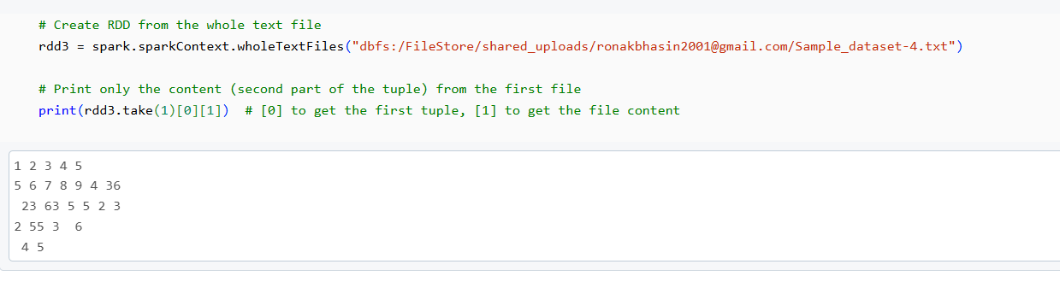

4.Creating an Empty RDD without Partitions
The emptyRDD() method creates an RDD with no data and no partitions.
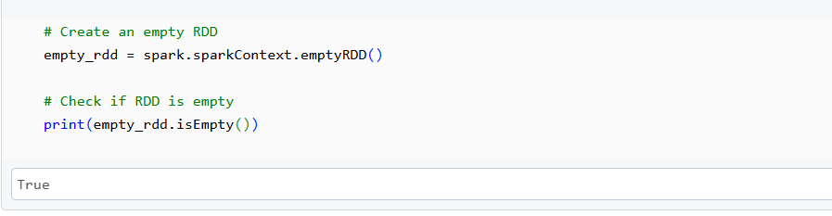

5. Creating an Empty RDD with Partitions
To create an empty RDD with specified partitions, use the parallelize() method with an empty list.
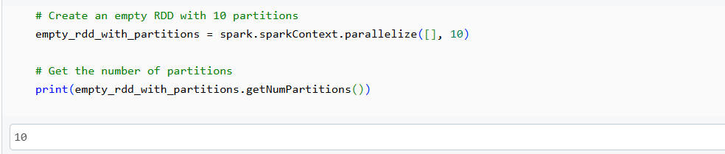

RDD Partitions
In Spark, RDDs (Resilient Distributed Datasets) are divided into smaller units called partitions. Each partition is a logical chunk of data that is processed in parallel across the cluster or local machine. The concept of partitions allows Spark to distribute computation across multiple nodes (or cores) efficiently.
Partitioning in Spark
- When you create an RDD using methods like parallelize(), textFile(), or wholeTextFiles(), Spark automatically splits the data into partitions based on the resource availability (number of cores and nodes in the cluster). For example, when running Spark on your laptop, the number of partitions created will be equal to the number of cores available on your system.
- Partitions are the smallest unit of work in Spark and are processed independently. The more partitions you have, the more parallelism you can achieve.
Default Partitioning Behavior
- parallelize(), textFile(), and wholeTextFiles(): These methods automatically split the data into partitions. The default partitioning is determined by the number of cores available in your system.
For example, if you run Spark locally with 2 cores, these methods will create 2 partitions by default.

1.getNumPartitions() Function
The getNumPartitions() function returns the number of partitions that the RDD is split into. This is useful for understanding how Spark distributes the data across the available resources.
Example:
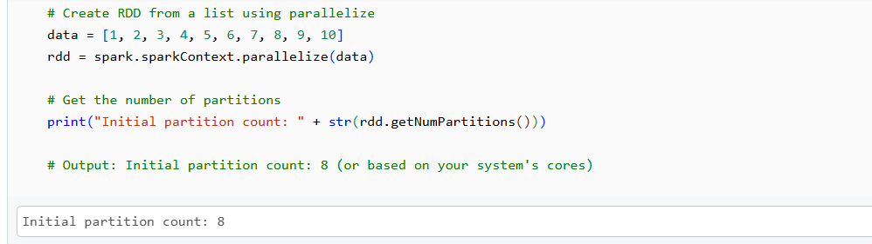

2. Setting Partitions Manually
In some cases, you might want to manually specify the number of partitions for an RDD. This can be done by passing the number of partitions as the second argument to the parallelize() method.
Example:
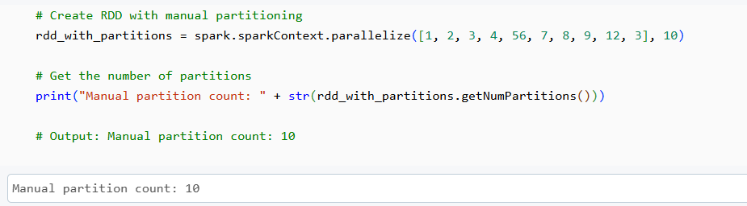

Repartition and Coalesce in PySpark
When working with large datasets in PySpark, it’s often necessary to adjust the number of partitions of an RDD to optimize performance. PySpark provides two methods to do this: repartition() and coalesce(). These methods allow you to increase or decrease the number of partitions in an RDD.
1. repartition()
- The repartition() method is used to increase or decrease the number of partitions of an RDD.
- Full Shuffle: repartition() involves shuffling data across all nodes, making it a costly operation in terms of performance. It’s typically used when you need a large number of partitions for better parallelism.
- This method always performs a full shuffle, meaning all data in the RDD is redistributed across the available partitions, which can lead to high overhead.

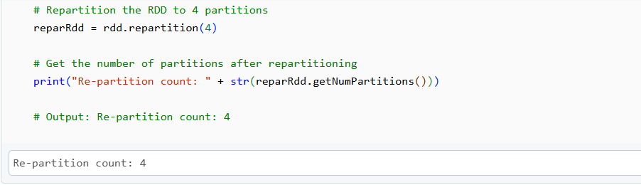

In the above code:
- The repartition(4) method increases or decreases the number of partitions to 4.
- The getNumPartitions() function confirms the number of partitions in the RDD.
2. coalesce()
- The coalesce() method is used to reduce the number of partitions in an RDD.
- Minimized Shuffle: Unlike repartition(), coalesce() performs a less expensive shuffle by merging existing partitions rather than shuffling data across all nodes.
- It’s best suited for reducing the number of partitions (e.g., when you have many small partitions and want to consolidate them into fewer partitions for output).
Example:
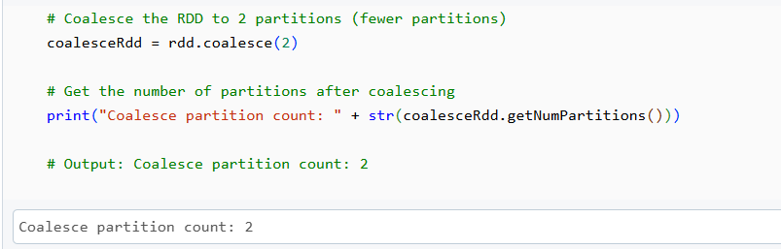

In the above code:
The coalesce(2) method reduces the number of partitions to 2. coalesce() only moves data between a minimum number of partitions (in this case, it will move data from only 2 nodes).
RDD Operations in PySpark
In PySpark, RDD (Resilient Distributed Dataset) operations are classified into two categories: Transformations and Actions.
1. RDD Transformations
Transformations are lazy operations, meaning they don't execute until an action is called on the RDD. Each transformation produces a new RDD, rather than modifying the existing one.
Common RDD Transformations
A. flatMap(): Flattens the resulting RDD after applying a function to each element. The result is a new RDD with individual records.
Example: Splitting each line of text into words.
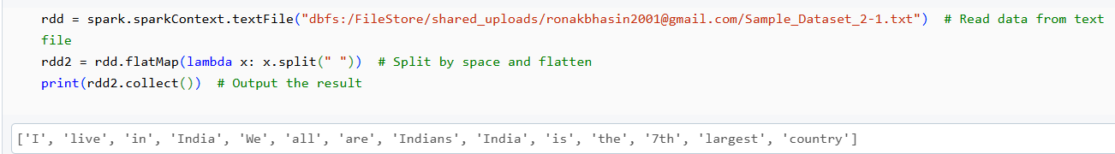

B. map(): Applies a function to each element and returns a new RDD with the same number of elements. In our example, each word is paired with a value of 1 to prepare for word count.
Example: Creating a key-value pair (word, 1) for each word.
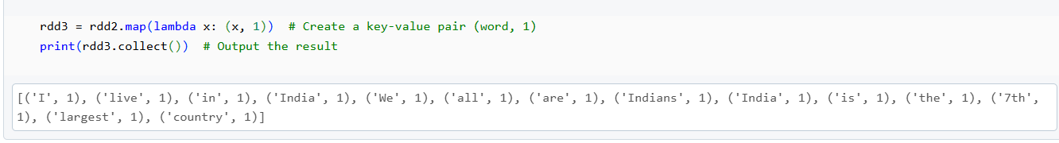

C. reduceByKey(): Combines the values for each key using a specified function. In the word count example, it sums the occurrences of each word.
Example: Summing the word counts.
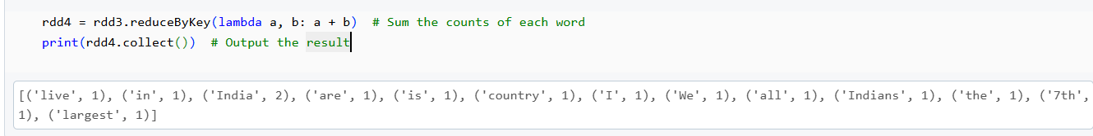

D. sortByKey(): Sorts the RDD by key. In our example, sorting by the count of each word (in reverse order of frequency).
Example: Sorting by the word count.
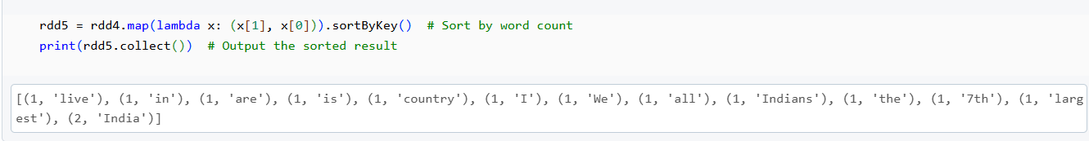

2.RDD Actions
Actions trigger the execution of transformations and return a result, which can either be returned to the driver program or saved to external storage.
Common RDD Actions
A. count(): Returns the number of records in the RDD.
Example: Counting the total records in the RDD.
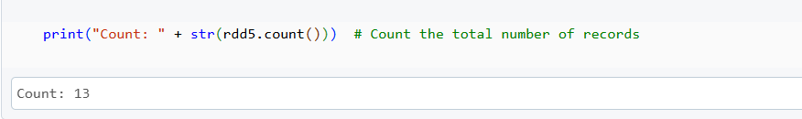

B. first(): Returns the first record of the RDD.
Example: Getting the first record in the RDD.
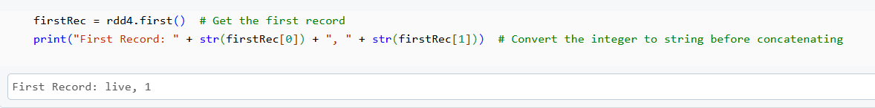

C. max(): Returns the record with the maximum value.
Example: Getting the record with the highest word count.
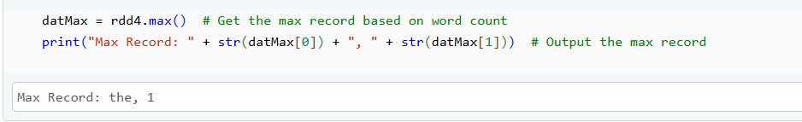
D. reduce(): Aggregates the elements in the RDD using a specified function. It reduces the RDD to a single value.
Example: Summing all word counts.
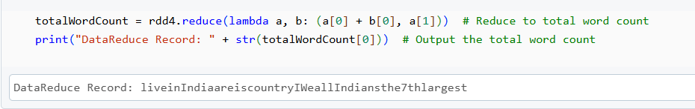

E. take(): Returns the first n records from the RDD.
Example: Getting the top 3 records.
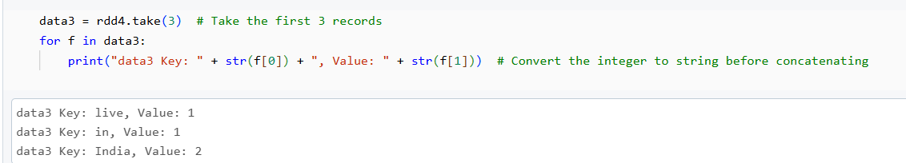

F. collect(): Returns all elements from the RDD as an array. Be cautious when using it on large datasets, as it can cause memory issues.
Example: Collecting all the data.
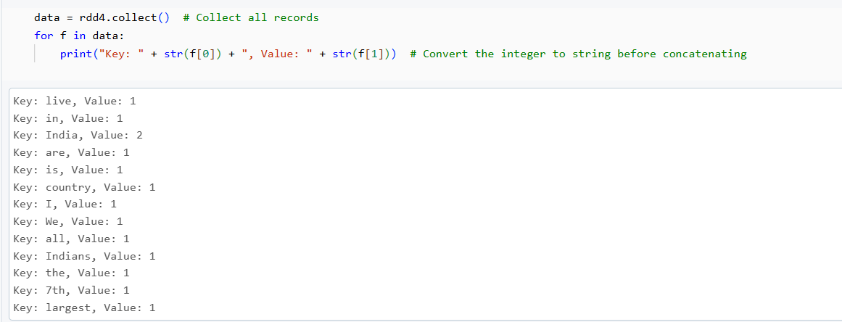

Types of RDD
- PairRDD:
- An RDD consisting of key-value pairs.
- Widely used for operations like grouping, aggregation, and joining based on keys.
- ShuffledRDD:
- Created during operations that require data movement between partitions, such as reduceByKey() or join().
- Involves shuffling data across the cluster.
- DoubleRDD:
- An RDD containing numeric data.
- Specialized for performing mathematical and statistical operations like sum(), mean(), and stdev().
- SequenceFileRDD:
- An RDD created by reading Hadoop Sequence files (binary key-value pair files).
- Commonly used in Hadoop ecosystems.
- HadoopRDD:
- An RDD created by reading data directly from Hadoop-compatible data sources like HDFS.
- ParallelCollectionRDD:
- An RDD created using the parallelize() method from a collection in memory.
- Mainly used for small datasets or testing.
Shuffle Operations
Shuffling is a process in PySpark that redistributes data across executors and machines, typically occurring when transformation operations like groupByKey(), reduceByKey(), and join() are applied to RDDs.
Cost of Shuffling: Shuffling is an expensive operation due to:
- Disk I/O: Temporary data is written to disk when memory overflows.
- Serialization/Deserialization: Data is serialized before transfer and deserialized afterward.
- Network I/O: Data is transferred between nodes over the network.
Shuffling Process:
- Map Tasks: Group all values for a single key in each partition.
- Memory Handling: Store results in memory; if memory is insufficient, use disk storage.
- Shuffling Data: Redistribute grouped data across partitions.
- Garbage Collection: Free up memory during intermediate steps.
- Reduce Tasks: Perform the reduction operation on grouped data in each partition.
Common Shuffle Trigger Operations:
repartition(), coalesce() groupByKey() reduceByKey() cogroup(), join()
Non-Shuffling Operations:
countByKey() does not trigger shuffling.
Shuffle Partition Size & Performance:
- Small Datasets: Reduce the number of shuffle partitions to avoid excessive tasks processing minimal data.
- Large Datasets: Increase partitions to distribute data evenly and avoid out-of-memory errors.
- Optimization: Iterative tuning is required to determine the optimal shuffle partition size.
Example:
- reduceByKey() with Shuffle:
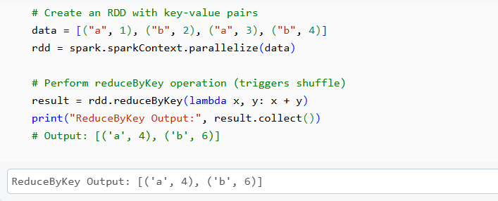
2. Repartitioning:
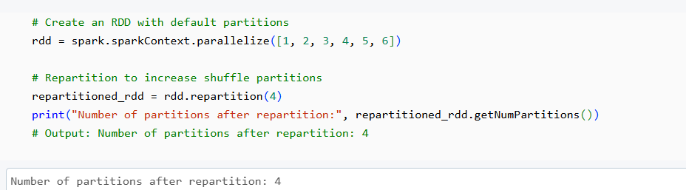
- Optimizing Shuffle Partitions:
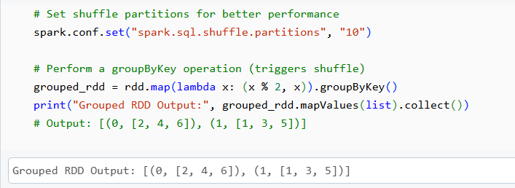

Persist and Cache RDD in PySpark
PySpark offers optimization techniques, such as caching and persisting, to enhance the performance of iterative and interactive jobs involving RDDs. These methods enable intermediate RDD computations to be reused, reducing redundant operations and improving efficiency.

1.RDD Cache
The cache() method saves RDD computations to the storage level MEMORY_ONLY by default. This stores data in the JVM heap as unserialized objects.

Working:
Internally, cache() calls the persist() method, using MEMORY_ONLY as the default storage level.
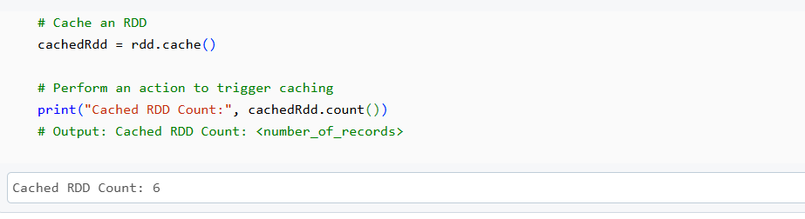

2.RDD Persist The persist() method allows specifying a storage level to store RDDs, providing flexibility in handling memory and disk storage.
Storage Levels:
- MEMORY_ONLY
- MEMORY_ONLY_SER
- MEMORY_AND_DISK
- MEMORY_AND_DISK_SER
- DISK_ONLY
- MEMORY_ONLY_2, MEMORY_AND_DISK_2, etc.
